

Configuring an Application Using the Datamaxx Web Services Software

1. Open Datamaxx V7 and Browse to Setup > Application Setup
2. 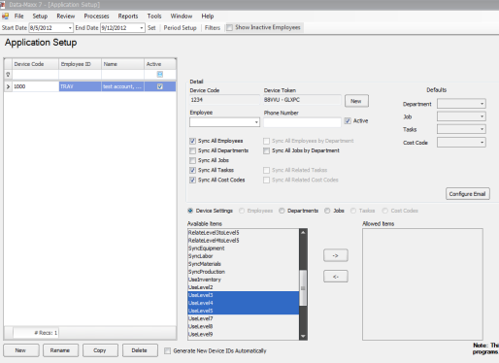Click the New Button in the Bottom Left
3. If you are using daily report leave it on Standard Configuration
4. Start with any device Naming Schema (i.e. 1000, then 1001, 1002 etc…)
5. Choose the Employee Assigned to the Device

Click the Right -> to add them to that device, Left <- to take them off

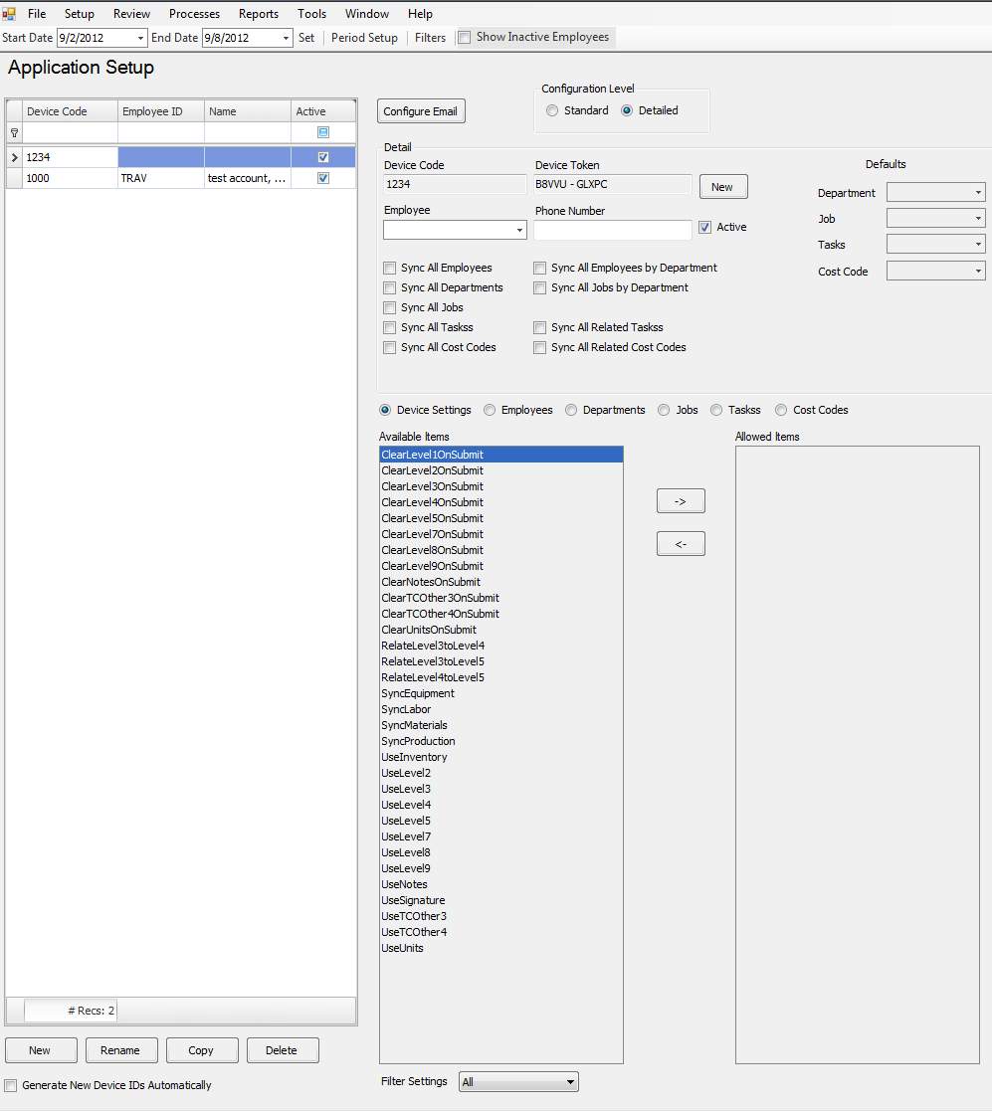

**KEY: \***

You can select what jobs you want to see in Daily Report

1. Previous setups can be copied and renamed for a speedier Setup by using the Copy Button at the bottom left of the screen
2. you need to set up a user in security and give them a password
3. From the datamaxx menu Choose Tools > Security > Users
4. Add a user name in the line below Name in the Users Column on the Left
5. Click add all forms disabled if they will not be logging into Datamaxx V7
6. Set a password
7. In the Employee ID column add there datamaxx Employee ID

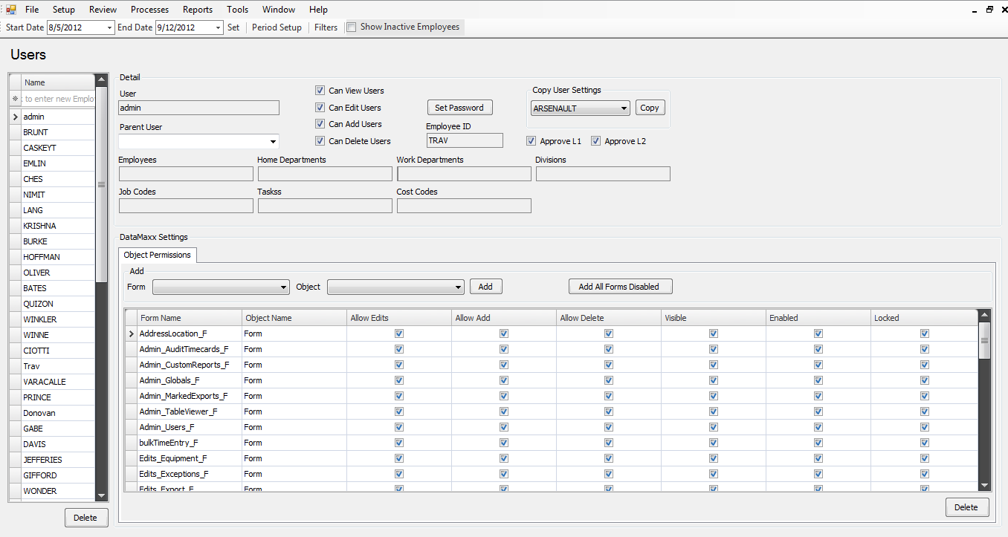

1. 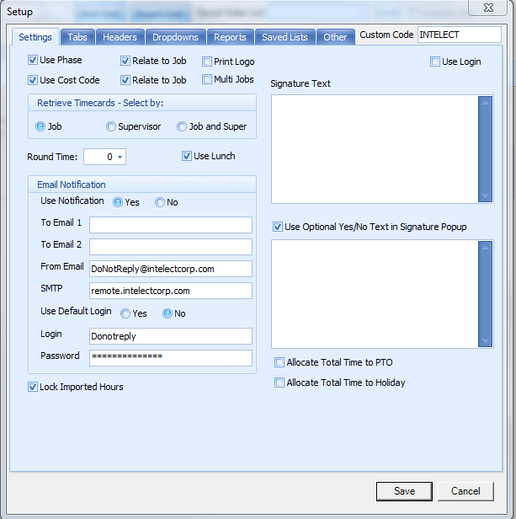In daily report click on setup and tick this box
2. Click save, Close and Reopen Daily report